LAB 9
TabBar, TabBarView, Drawer, ListView
- TABBAR + TABBARVIEW:
Insight_screen
TabController Setup:
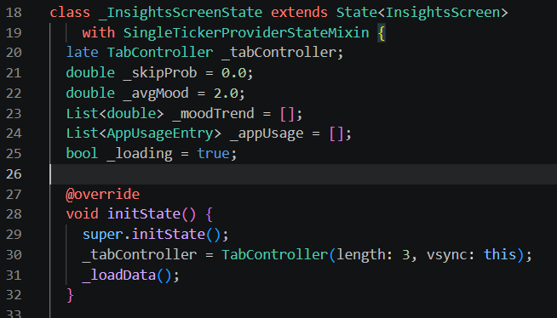
TabBar
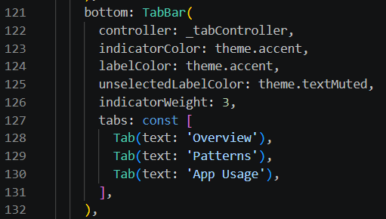

TabBarView (3 tabs)
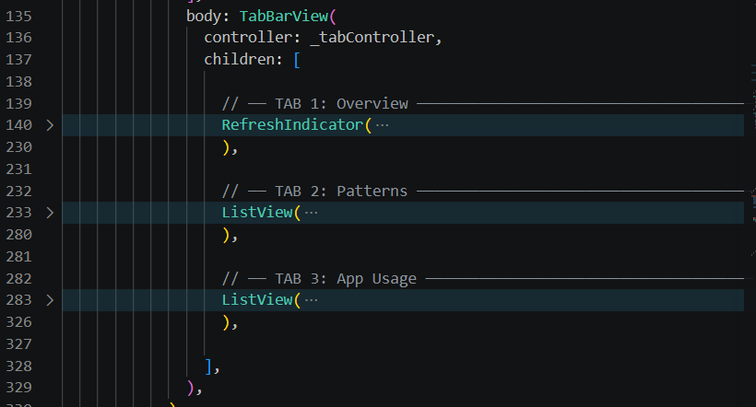
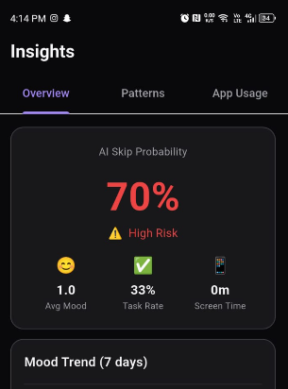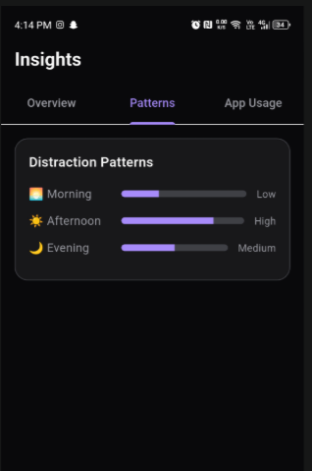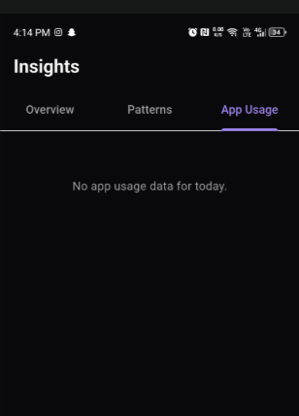
Tab Bar + View:
- Insights screen has 3 swipeable tabs at the top.
- "Overview" shows AI skip % + mood chart.
- "Patterns" shows morning/afternoon/evening distraction bars.
- "App Usage" shows phone screen time.
- Tabs have accent underline indicator and animate on switch.

2. DRAWER + LISTVIEW
Main_screen
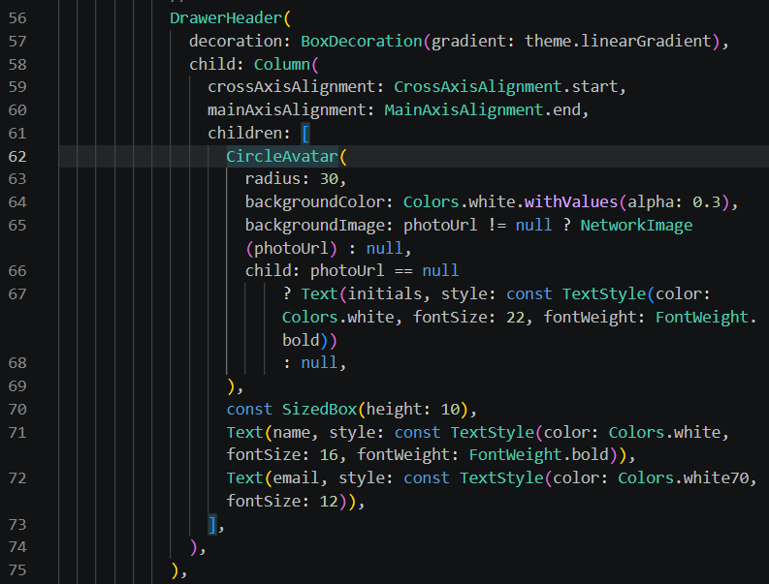
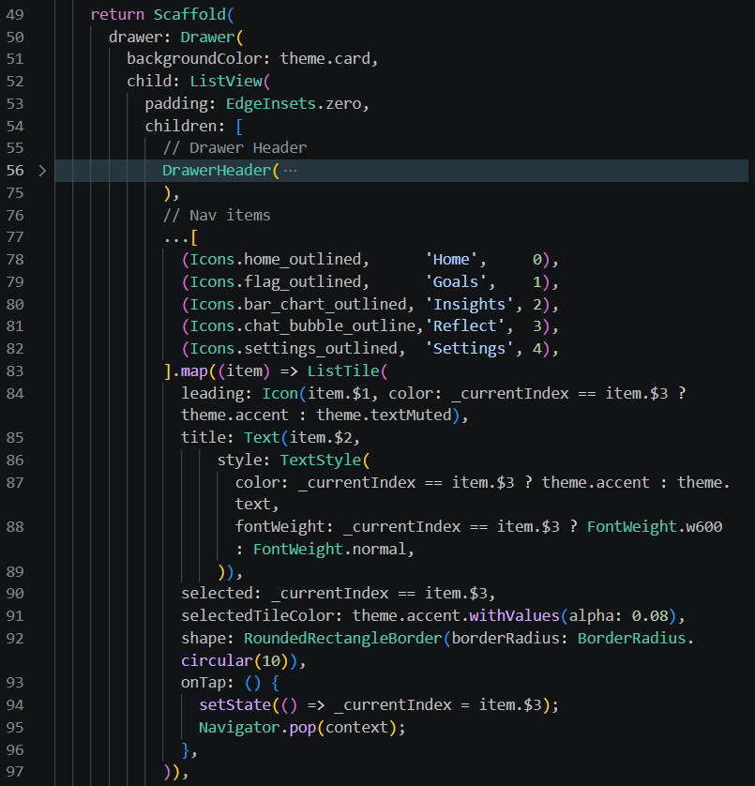
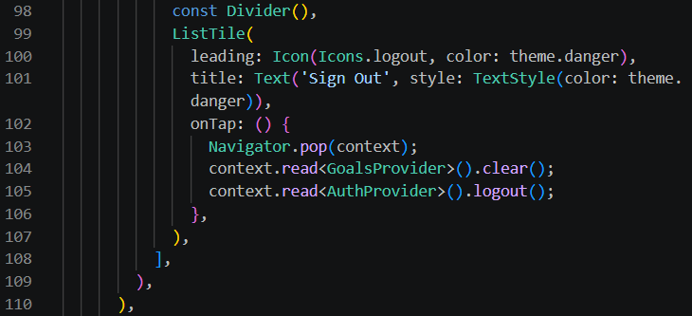

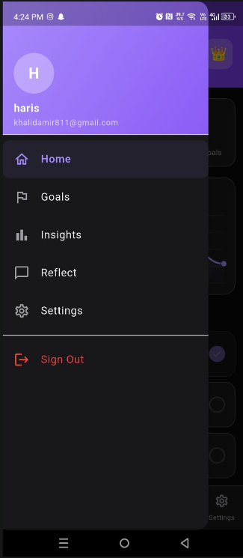
Drawer + ListView:
- Swipe right from left edge drawer slides in from left.
- Shows gradient header with profile photo + name + email.
- screen is highlighted with accent color.
- Bottom has a red Sign Out option.
- Tapping any item navigates to that screen and closes the drawer

